NWVARC February Rally (for current financial members only)
Saturday 29th February, 2020. (Saturday only this year)
RnR - Ride & Relax at Grace’s Bend, Nangiloc

Location: Colignan, 68 Briggs Lane, Denise Young’s property on the river
Rally cost: $5 per person for all those who attend - funds are payable to NWVARC or Kathryn on the day as this is a fund raiser event.
Itinerary – You choose the activity/ies you want to do….

10 am (subject to weather) – trail ride around Graces bend (approx. 50 min walking pace only)

11.30? – Cool off in the pool after your ride

12.30 - Lunch provided at a cost of $5 per person
(Fresh buns, meat and salad, includes some drink).

2.00 pm – Meditation and mindfulness with Kathryn
2.30 pm – Sekhem healing for horse demonstration with Denise

3-5pm – Second Trail Ride/Arena work/Relax and Swim in pool, depending on request of attender, Denise has a nice full size dressage arena to practice on).

5pm finish up, pack up and head home rested and revived.

Facilities include:
Plenty of grass for grazing, fridge space and amenities. Some yards available

See next page for directions…
Call or SMS Kathryn on 0409 802802 if attending
Contact Denise 0429841241 for parking and facility info

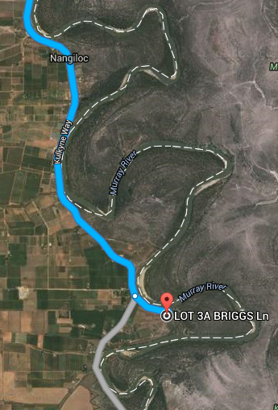
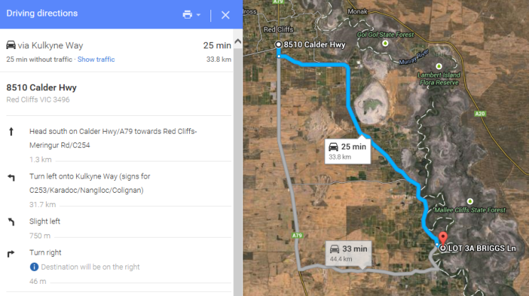
From Red Cliffs Direction

Directions 60mins from from Mildura (50- Mildura). The Nangiloc, Colignan road is a few kms past Red Cliffs, turn left off the Calder Hwy and follow signs to Nangiloc (30km). Turn left into Briggs Lane (5kms past the Nangiloc shop). It is the last house before river bend (68).

Directions from Ouyen (50-60 mins from Ouyen). Turn right into Boonoonar road (60 km from Ouyen (5km past Nowingi)). Follow signs to Colignan (16km) Travel through Colignan until past the 100 km sign, turn right into Briggs Lane. Beware of oncoming traffic as there is a blind “S” bend. We are last house before river bend

