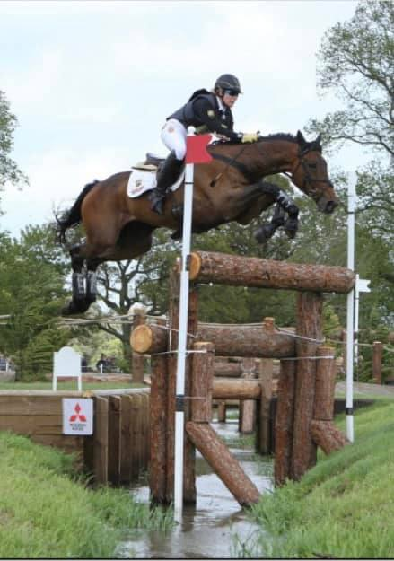

Save the Date
April Rally - 23 & 24
Wendy Schaffer-McDonald SJ & XC Clinic
Show Jumping Saturday, Cross Country Sunday
$55 per lesson, 4 riders per group
Contact Lara Collins if you are interested

